Artificial Intelligence
Unit 3 – Representation of Knowledge
----------------------------

Representation of Knowledge: Knowledge representation issues, predicate logic- logic programming, semantic nets- frames and inheritance, constraint propagation, representing knowledge using rules, rules-based deduction systems. Reasoning under uncertainty, review of probability, Bayes’ probabilistic interferences and Dempster-Shafer Theory theory.

Major issues in knowledge representation in AI
Why Knowledge Representation is Important for Problem Solving:

What is Knowledge Representation?
A way to store facts and rules so a computer can think and act.
- Turn problems into data:
Computers can search that data to find answers.
Example: Cities = dots, roads = lines → find the shortest path.
- Make new facts from old ones (inference):
If we know “Tweety is a bird” and “birds can fly,” we get “Tweety can fly.”
- Handle limits and choices (constraints):
Stops bad options.
Example: Class size must be ≤ room capacity when making a timetable.
- Explain answers:
Shows why a result was chosen.
Example: “Diagnosis because symptoms A, B, C matched Rule-3.”
- Share common meanings:
Different systems agree on terms.
Example: A medical ontology makes “BP” mean the same thing everywhere.

Major Issues in Knowledge Representation in AI

- Incomplete Knowledge
- Real-world knowledge is often partial or missing.
- Example: A medical expert system may not have all the symptoms for a rare disease.
- Explanation: The system doesn’t know everything, so it can miss the correct diagnosis.
- Uncertainty
- Information may be imprecise, vague, or probabilistic.
- Example: A patient may have fever, but the degree and cause are uncertain.
- Explanation: We aren’t fully sure what’s true, so conclusions can only be “likely,” not certain.
- Scalability / Complexity
- Large knowledge bases are difficult to maintain, update, and process efficiently.
- Example: Representing all facts about natural language semantics is extremely complex.
- Explanation: There’s too much to store and manage, so the system becomes heavy and slow.
- Consistency
- Contradictory knowledge may exist.
- Example: “All birds fly” vs. “Penguins are birds that don’t fly.”
- Explanation: Rules can clash; one rule says “yes,” another says “no.”
- Reasoning Efficiency
- Even if knowledge is represented well, reasoning over it must be efficient.
- Example: Logic-based systems may take too long to infer answers in real time.
- Explanation: The system might be correct but too slow to be useful.
- Context Dependence
- Meaning of knowledge may change depending on context.
- Example: The word “bank” could mean a financial institution or riverbank.
- Explanation: The same word can mean different things; the system must know the situation.
- Knowledge Acquisition Bottleneck
- Extracting, formalizing, and updating knowledge is slow and resource-intensive.
- Example: Encoding expert medical rules into an AI system requires domain experts.
- Explanation: Getting expert knowledge into the system takes a lot of time and people.
- Expressiveness vs. Computability Trade-off
- More expressive representations (like natural language) are harder to process, while more structured ones (like logic) may be less flexible.
- Explanation: If it’s easy for humans, it’s hard for machines; if it’s easy for machines, it’s less natural for humans.

Note: Knowledge representation is at the core of AI problem solving. Without it, AI cannot store, interpret, or reason about facts to solve real-world problems. But designing a representation that is complete, consistent, efficient, and scalable remains a major challenge.

Case Study: How Knowledge Representation helps solve a problem
Task: Simple illness guess (cold Vs. flu)
Representation (IF-THEN rules):
- R1: Fever ∧ BodyAche → Flu
- R2: RunnyNose ∧ Sneezing → Cold
- R3 (default): Fever → LikelyFlu (unless evidence against)
Facts (patient P): Fever, Sneezing
Reasoning:
- From R3: LikelyFlu(P) (default).
- From R2 needs RunnyNose AND Sneezing. We only know Sneezing. → Can’t conclude Cold.
- Incomplete knowledge issue: Not knowing RunnyNose blocks rule R2.
- If new fact arrives: BodyAche → Use R1 to confirm Flu.
- If we later learn P is a penguin (even at age 2), we take back the default “P can fly.” That’s non-monotonic reasoning.

Predicate logic in AI and apply Logic Programming
What is Predicate Logic (First-Order Logic, FOL)?
A formal way to write facts and rules about the world so a machine can reason.
Building blocks
- Constants: specific objects — alice, nepal, cs101
- Variables: placeholders — X, Y
- Predicates: properties/relations — Parent(alice,bob), Enrolled(bob,cs101)
- Functions (optional): build new objects — FatherOf(bob)
- Connectives:∧(and), ∨(or), →(implies), ¬(not)
- Quantifiers:∀X (for all X), ∃Y (there exists Y)
Example (English → FOL)
- “All humans are mortal.” → ∀x (Human(x) → Mortal(x))
- “Socrates is a human.” → Human(socrates)
- From these, conclude: Mortal(socrates).
Why use it?
Clear meaning, supports inference, and scales better than plain propositional logic.

From FOL to Logic Programming (Prolog-style):
Logic programming uses a restricted form of logic called Horn clauses:
- Fact:parent(alice, bob).
- Rule:grandparent(X, Z) :- parent(X, Y), parent(Y, Z).
(“X is Z’s grandparent if X is parent of Y and Y is parent of Z.”)
- Query/Goal: ?- grandparent(alice, Z).
How it works
- Unification: match patterns by finding variable bindings (X=alice, Y=bob, …).
- SLD-resolution & backtracking: try rules left to right; if a path fails, backtrack to try alternatives.
- Closed-world assumption & negation-as-failure: if Prolog can’t prove it, it assumes false (for that query).

Example – 1: Step-by-Step (Family Relations):
Knowledge Base (facts + rules)
% Facts
parent(alice, bob).
parent(bob, cara).
parent(alice, dan).
parent(dan, emma).

female(alice).
male(bob).
male(dan).

% Rules
mother(M, C) :- parent(M, C), female(M).
father(F, C) :- parent(F, C), male(F).
grandparent(G, K):-parent(G, P), parent(P, K).
ancestor(A, D) :- parent(A, D).
ancestor(A, D) :- parent(A, X), ancestor(X, D).

Query 1: Who are Alice’s grandchildren?
?- grandparent(alice, K).

Derivation (informal trace)
- Goal: grandparent(alice, K)
- Use rule: grandparent(G,K) :- parent(G,P), parent(P,K)
- Unify G = alice → subgoals: parent(alice,P) and parent(P,K)
- From facts, parent(alice,bob) and parent(alice,dan):
  - Case A: P=bob → need parent(bob,K) → from facts parent(bob,cara) ⇒ K=cara
  - Case B: P=dan → need parent(dan,K) → from facts parent(dan,emma) ⇒ K=emma
- Answers: K = cara ; K = emma. (with backtracking)

Query 2: Who is Cara’s father?
?- father(F, cara).
Derivation
- father(F,C) :- parent(F,C), male(F)
- From facts: parent(bob,cara) and male(bob) ⇒ F = bob.

Example – 2: A Tiny Rule-Based Eligibility (to show inference chain)
Knowledge Base
% Facts
student(rahul).
gpa(rahul, 8.3).
income_family(rahul, low).
attendance(rahul, 0.92). % 92%

% Helper predicates
good_gpa(S) :- gpa(S,G), G >= 8.0.
high_attendance(S) :- attendance(S,A), A >= 0.85.

% Scholarship rule
eligible_scholarship(S) :-
student(S),
good_gpa(S),
high_attendance(S),
income_family(S, low).

Query
?-eligible_scholarship(rahul).

Reasoning
- student(rahul) ✔
- gpa(rahul,8.3) ⇒good_gpa(rahul) ✔
- attendance(rahul,0.92) ⇒high_attendance(rahul) ✔
- income_family(rahul,low) ✔
- All subgoals satisfied ⇒Rahul is eligible.

Semantic Networks
- A semantic network is a graph of concepts (nodes) connected by labeled links (edges) that describe how those concepts are related.
- It’s used in AI for storing meaning, inheritance (passing properties down a hierarchy), and explainable reasoning.

- A semantic network represents knowledge as a graph:
- Nodes = objects/concepts (e.g., Bird, Penguin, Wing).
- Labeled edges = relationships (e.g., is-a, has-part, instance-of, can).

- It’s great for:
- Modeling hierarchies (is-a links for inheritance)
- Showing part–whole (has-part)
- Capturing abilities/properties (can, lives-in)
- Doing simple reasoning by following links.
- A semantic network is a diagram that uses circles for concepts and arrows for relationships (e.g., is-a, instance-of, has-part), enabling property inheritance and exception handling, as shown in the figure below.
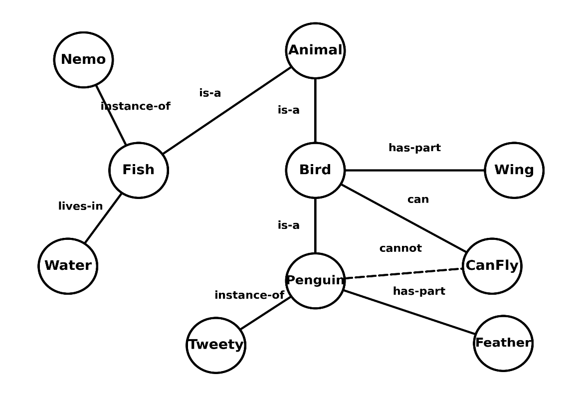

Figure: Semantic Network
- The diagram is a semantic network where circles are concepts or specific examples and arrows show relationships.
- Bird and Fish are both “is-a” kinds of Animal, and Penguin “is-a” Bird, so a penguin is also an animal.
- Tweety is an “instance-of” Penguin and Nemo is an “instance-of” Fish, meaning they inherit their class properties.
- Class properties are attached by labeled links: Bird “has-part” Wing and, by inheritance, penguins also have wings; Penguin additionally “has-part” Feather.
- Birds generally “can” Fly, but the dashed “cannot” link from Penguin to canFly marks an exception, so Tweety (a penguin) does not fly. Fish “lives-in” Water, so Nemo lives in water.

How relationships are represented
- is-a (subclass)
  - Bird → Animal (is-a), Penguin → Bird (is-a)
  - Meaning: every Penguin is a Bird, and every Bird is an Animal.
- instance-of (object)
  - Tweety → Penguin (instance-of)
  - Tweety is a particular penguin (an object, not a class).
- has-part (part–whole)
  - Bird → Wing (has-part), Penguin → Feather (has-part)
  - Birds have wings; penguins have feathers.
- can / cannot (ability/constraint)
  - Bird → CanFly (can) encodes the typical ability.
  - Penguin → CanFly (cannot) (dashed) encodes the exception: penguins don’t fly.
- lives-in (relation to environment)
  - Fish → Water (lives-in)
  - Class-level ecological fact.

Step-by-step reasoning example (inheritance + exception)
Query: “Can Tweety fly?”
- Step 1: Follow Tweety → Penguin (instance-of) → check Penguin.
- Step 2: Penguin has a cannot link to CanFly → conclude Tweety cannot fly.
- (If the exception were absent, we’d inherit the typical ability via
Tweety → Penguin → Bird → CanFly (can) and answer yes.)
Query: “Is Tweety an animal?”
- Tweety (instance-of) Penguin → (is-a) Bird → (is-a) Animal
- By transitivity of is-a, yes.
Query: “What parts does a Penguin have?”
- Direct: Penguin → Feather (has-part)
- Inherited from Bird: Bird → Wing (has-part) ⇒ Penguins have wings (even if they don’t fly).

Semantic Network View:
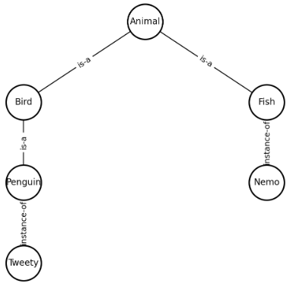
Bird --has-part--> Wing
Bird --has-part--> Feather
Fish --lives-in--> Water
Bird --can--> CanFly
Penguin --cannot--> CanFly

- A semantic net is a labeled graph. Inference follows the links (with inheritance and exceptions) to reason about objects and their relationships.

Frame-based Knowledge Representation
Frame-Based Knowledge Representation:
- Frames are like templates for things (objects, classes, situations).
- Each frame has slots (properties) with values.
- Frames can also have defaults, rules/limits, and small procedures that fill a value when needed.
- A frame can point to a parent frame and inherit its properties.
Why use frames?
- Easy to model real-world hierarchies (like Animal → Mammal → Dog).
- Keep related facts together in one place.
- Support defaults and exceptions (typical case + special cases).
- Combine facts with small procedures (how to compute a value).
What’s inside a frame?
- Name: what the frame is about (e.g., Dog, sheru).
- Slots: properties (e.g., has_legs, diet, sound).
- Slot details (optional): default value, allowed types, constraints, small procedure.
- Links:
  - is-a: instance of a class (sheru is-a Dog)
  - ako (“a kind of”): subclass link (Dog ako Mammal)
  - part-of: component link (e.g., Wheel part-of Car)
How inheritance works (the basic idea)
When you need a slot’s value:
- Check the instance frame first.
- If missing, check its class frame.
- If still missing, go up the parents (via ako/is-a) until you find a value.
- Closer values override higher-level defaults.
- If there are multiple parents, use a clear rule to break ties (order or an explicit policy).

Worked example: Animals → Mammals → Dogs (with an exception)
1) Class hierarchy
Thing
└── Animal
├── Bird
└── Mammal
├── Dog
└── Bat (a Mammal that can fly)

2) Frames (compact notation)
Frame: Animal
- slots:
  - has_cells := true (default)
  - blood_type := warm_blooded (default)
  - movement := {walk, run, swim} (typical)
  - can_fly := false (default)
  - diet := varies (default)
Frame: Bird ako → Animal
- slots:
  - has_feathers := true
  - lays_eggs := true
  - can_fly := true (default, with exceptions like Penguin)
Frame: Mammal ako → Animal
- slots:
  - has_hair := true
  - gives_milk := true
  - lays_eggs := false
  - can_fly := false (reinforces Animal default)
Frame: Dog ako → Mammal
- slots:
  - sound := "bark"
  - diet := carnivore (overrides Animal’s vague default)
Frame: Bat ako → Mammal
- slots:
  - can_fly := true (exception overriding Mammal default)
  - diet := insectivore (typical)
Frame: sheru is-a → Dog (an instance)
- slots:
  - color := brown
  - (no explicit can_fly, has_hair, etc.)
3) Inheritance in action (query → answer)

Q1. Does sheru have hair?
Lookup order:
- sheru.has_hair? (missing) → look at class Dog (missing) → parent Mammal.has_hair = true.
A: true (inherited from Mammal).

Q2. Can sheru fly?
- sheru.can_fly? (missing) → Dog.can_fly? (missing) → Mammal.can_fly = false.
A: false (inherits Mammal default).

Q3. What’s sheru’s diet?
- sheru.diet? (missing) → Dog.diet = carnivore (class override over Animal’s vague default).
A: carnivore.

Q4. Can a Bat fly? Why is this an exception?
- Bat.can_fly = true overrides Mammal.can_fly = false.
A: true due to a specific subclass override (exception handling).

Multiple inheritance:

Suppose RobotDog inherits from both RobotPet and Dog:

Frame: RobotPet
- power_source := battery
- sound := "beep"

Frame: RobotDog ako → {Dog, RobotPet}
- conflict on sound: Dog.sound = "bark" vs RobotPet.sound = "beep"
Resolution options:
- Precedence order in parents (e.g., prefer Dog over RobotPet) → sound = "bark".
- Explicit override in RobotDog (e.g., set sound = "bark-beep").
- Policy: “Prefer most specific, else first-listed parent.”

Constraint Propagation to a suitable Constraint Satisfaction Problem (CSP)
- It cuts down choices early, so CSPs solve faster with less backtracking.
- It’s used in real tasks like timetables, Sudoku, routing, and scheduling.
- Constraint Satisfaction Problem (CSP): set of variables, each with a domain of values, and constraints that restrict which combinations of values are allowed.
- Constraint propagation: automatic pruning of domain values that cannot participate in any solution, thus reducing search.
CSP Setup:India Map-Coloring
- Variables (states/UT): GJ (Gujarat), RJ (Rajasthan), MP (Madhya Pradesh), MH (Maharashtra), UP (Uttar Pradesh), HR (Haryana), DL (Delhi)
- Domains (initial): each {R, G, B} (Red, Green, Blue)
- Constraints (adjacent regions must be different):
GJ–RJ, GJ–MP, GJ–MH, RJ–MP, RJ–HR, RJ–UP, HR–DL, HR–UP, UP–DL, MP–UP, MP–MH
(DL borders HR & UP; no direct RJ–DL or DL–MP)

Step 0 — Initial Domains
GJ:{R,G,B} RJ:{R,G,B} MP:{R,G,B}
MH:{R,G,B} UP:{R,G,B} HR:{R,G,B} DL:{R,G,B}

Step 1 — Assign GJ = R, then Forward Check
Decision: GJ = R
Neighbors of GJ: RJ, MP, MH must be ≠ R
RJ:{G,B} MP:{G,B} MH:{G,B}
UP:{R,G,B} HR:{R,G,B} DL:{R,G,B}

Step 2 — Assign RJ = G, then Forward Check
Decision: RJ = G (from {G,B})
Neighbors of RJ: GJ, MP, HR, UP
- GJ = R (ok)
- MP ≠ G → MP:{B} (forced)
- HR ≠ G → HR:{R,B}
- UP ≠ G → UP:{R,B}
State now:
GJ:R
RJ:G
MP:{B}
MH:{G,B}
UP:{R,B}
HR:{R,B}
DL:{R,G,B}

Step 3 — Propagate MP = B (forced), then Cascade
Assign: MP = B
Neighbors of MP: GJ, RJ, UP, MH
- GJ = R (ok)
- RJ = G (ok)
- UP ≠ B → UP:{R} ⇒UP = R
- MH ≠ B → MH:{G} ⇒MH = G
State:
GJ:R
RJ:G
MP:B
MH:G
UP:R
HR:{R,B}
DL:{R,G,B}

Step 4 — Propagate UP = R
Neighbors of UP: RJ, HR, DL, MP
- RJ = G (ok)
- MP = B (ok)
- HR ≠ R → HR:{B} ⇒HR = B
- DL ≠ R → DL:{G,B}
State:
GJ:R
RJ:G
MP:B
MH:G
UP:R
HR:B
DL:{G,B}

Step 5 — Propagate HR = B
Neighbors of HR: RJ, UP, DL
- RJ = G (ok)
- UP = R (ok)
- DL ≠ B and (already ≠ R from UP) → DL:{G} ⇒DL = G

Final Coloring (all assigned after two choices!)
GJ = R
RJ = G
MP = B
MH = G
UP = R
HR = B
DL = G

Table — After Each Step
Step | GJ | RJ | MP | MH | UP | HR | DL
0 (initial) | {R,G,B} | {R,G,B} | {R,G,B} | {R,G,B} | {R,G,B} | {R,G,B} | {R,G,B}
1 (GJ=R + FC) | R | {G,B} | {G,B} | {G,B} | {R,G,B} | {R,G,B} | {R,G,B}
2 (RJ=G + FC) | R | G | {B} | {G,B} | {R,B} | {R,B} | {R,G,B}
3 (propagate MP=B) | R | G | B | {G} | {R} | {R,B} | {R,G,B}
4 (propagate UP=R) | R | G | B | G | R | {B} | {G,B}
5 (propagate HR=B) | R | G | B | G | R | B | {G}
Final | R | G | B | G | R | B | G

Conclusion:
- Propagating constraints after each assignment removes impossible values and quickly fixes many variables.
- In the India map example, just two choices forced all others—showing how simple and powerful this idea is.
How the Search Space is Reduced?
- Start: 7 regions × 3 colors ⇒ 3⁷ = 2187 possibilities.
- After GJ = R: neighbors lose R ⇒ about 216 possibilities.
- After RJ = G: more pruning (MP forced, others shrink) ⇒ about 24.
- Cascade (forced values): UP, MH, HR, DL get fixed ⇒ 1 final coloring.

Note:
- Set one region’s color → its neighbors can’t use that color.
- A neighbor may have only one color left; we set it, which then limits its neighbors too — a domino effect.
Knowledge Representation using Rules
Knowledge Representation with Rules:
What is rule-based KR?
We store knowledge as IF–THEN rules plus facts.
- Fact (working memory): a true statement now.
Example: student(rahul), gpa(rahul)=8.3
- Rule (knowledge base): pattern → conclusion/action.
Example: IF student(X) AND gpa(X) ≥ 8.0 THEN good_gpa(X)
Inference engine applies rules to facts to infer new facts (deduction).

How inference works (two common styles)
- Forward chaining (data-driven): Start from known facts, fire rules that match, keep adding conclusions until goal reached.
- Backward chaining (goal-driven): Start from a query/goal, look for rules that could prove it, then try to prove their preconditions.

Example: Scholarship Eligibility (step-by-step)
Facts (given)
student(rahul)
gpa(rahul) = 8.3
attendance(rahul) = 0.92
family_income(rahul) = low
Rules (IF–THEN)
- IF gpa(X) ≥ 8.0 THEN good_gpa(X)
- IF attendance(X) ≥ 0.85 THEN high_attendance(X)
- IF student(X) AND good_gpa(X) AND high_attendance(X) AND family_income(X)=low THEN eligible_scholarship(X)
- (optional disqualifier)
IF attendance(X) < 0.75 THEN not_eligible(X)
Forward chaining trace:
Start WM (working memory):
{ student(rahul), gpa(rahul)=8.3, attendance(rahul)=0.92, family_income(rahul)=low }
- Rule 1 matches gpa(rahul)=8.3 → add good_gpa(rahul)
WM ← …, good_gpa(rahul)
- Rule 2 matches attendance(rahul)=0.92 → add high_attendance(rahul)
WM ← …, high_attendance(rahul)
- Rule 3 now fully matches (student, good_gpa, high_attendance, family_income=low)
→ add eligible_scholarship(rahul)
- Rule 4 does not match (attendance is not < 0.75)
Conclusion:eligible_scholarship(rahul) is true (derived).

Backward chaining sketch (same goal)
Goal:eligible_scholarship(rahul)
- Look at Rule 3 (it concludes the goal). Need to prove:
  - student(rahul) ✔
  - good_gpa(rahul) → from Rule 1 needs gpa(rahul) ≥ 8.0 ✔ (8.3)
  - high_attendance(rahul) → from Rule 2 needs attendance ≥ 0.85 ✔ (0.92)
  - family_income(rahul)=low ✔
All subgoals proved → goal holds.

Reasoning under uncertainty in AI
What is “reasoning under uncertainty”?
- It’s how AI represents, updates, and uses incomplete or noisy information to make the best possible decision.
- Instead of binary true/false facts, we carry degrees of belief (e.g., probabilities) and choose actions that maximize expected benefit (utility).
Why it matters?
- Real data are messy: sensors fail, users omit details, tests have errors.
- Avoids brittle yes/no logic: supports graded conclusions.
- Enables rational action: pick the action with highest expected utility given current beliefs.
- Quantifies value of information: decide when another test/measurement is worth it.
Common tools:
- Probability & Bayes’ rule (posterior = prior × likelihood / evidence)
- Bayesian networks/HMMs, MDPs/POMDPs (decision making over time)
- Also: fuzzy logic, Dempster–Shafer, credal sets (alternatives to classic probability)

Worked example: Medical test → treat, don’t treat, or test again?
Goal: Decide what to do after a positive screening test.
Given
- Disease prevalence (prior): P(D)=0.01
- Test-1: sensitivity 0.95, specificity 0.90 (false-positive 0.10)
- Utilities (arbitrary units):
  - Treat & diseased: +100 (benefit)
  - Treat & healthy: –20 (side-effects/cost)
  - Don’t treat & diseased: –100 (missed treatment)
  - Don’t treat & healthy: 0
1) Update belief after the positive result (Bayes)
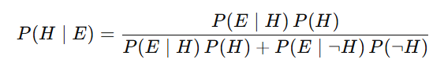
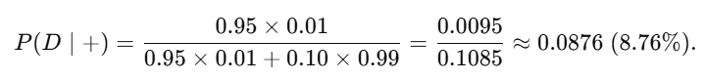
2) Decision threshold (treat Vs don’t treat)
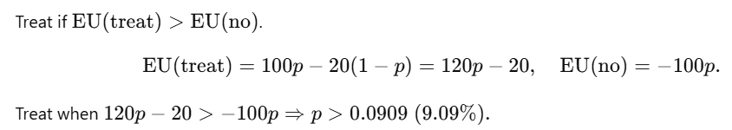
Our posterior is 8.76%, just below the threshold ⇒don’t treat yet.
3) Should we do a better second test?
Assume Test-2: sensitivity 0.99, specificity 0.99; test cost = –2 utility.
- Current odds after Test-1: 0.0876 / 0.9124=0.096.
- If Test-2 positive: likelihood ratio =0.99/0.01=99.
New odds =0.096×99=9.51⇒P≈0.905.
This is ≫ 9.09%, so we treat.
EU≈120(0.905)−20≈+88.6.
- If Test-2 negative: LR =0.01/0.99≈0.0101.
New odds =0.096×0.0101≈0.0010⇒P≈0.001.
Below threshold ⇒don’t treat.
EU≈−100(0.001)≈−0.10.

Probability that Test-2 is positive given current belief:
P(+2)=0.0876×0.99+0.9124×0.01≈0.0959.
Expected utility of “test again”
EU(test)=−2+0.0959×88.6+0.9041×(−0.10)≈+6.4.
Compare options now
- Treat now: ≈−9.49
- Don’t treat now: −100×0.0876=−8.76
- Do Test-2: ≈+6.4 Best

Bayes’ probabilistic inference
Bayes’ inference updates what you believe before (prior) after seeing evidence (likelihood) to get a new belief (posterior).
Rule (Bayes’ theorem):
P(H∣E)= (P(E∣H) P(H)) / (P(E∣H) P(H)+P(E∣¬H) P(¬H))​
- H: hypothesis, E: evidence
- P(H): prior belief, P(E∣H): likelihood, P(H∣E): posterior belief
Example: If a disease is 1% (P(H)=0.01, test is 95% sensitive and 90% specific, then after a positive test the chance of disease is about 8.8%, not 95% (because positives can occur in healthy people).

Bayes’ probabilistic inference — Example
Setup
- Hypothesis H: person has the disease.
- Prior (prevalence): P(H)=0.01 (1%).
- Test sensitivity: P(+∣H)=0.95.
- Test specificity: 0.90⇒P(+∣¬H)=0.10 (false-positive rate).
Step 1 — Write Bayes’ rule
P(H∣+)= (P(+∣H) P(H)) / (P(+∣H)P(H)+P(+∣¬H) P(¬H))​
Step 2 — Plug in numbers
- P(+∣H)P(H)=0.95×0.01=0.0095.
- P(+∣¬H)P(¬H)=0.10×0.99=0.099
- Denominator =0.0095+0.099=0.1085.
Step 3 — Compute posterior
P(H∣+)=0.0095 / 0.1085≈0.0876 (about 8.8%)
Meaning: Even with a good test, a positive result gives only ~8.8% chance of disease because the disease is rare (base-rate effect).
Frequency check
- Out of 10,000 people: 100 sick → 95 test positive; 9,900 healthy → 990 false positives.
- Total positives =95+990=1,085.
- Posterior =95/1,085≈8.8% (same result).

Odds form
- Prior odds =0.01 / 0.99≈0.0101
- Bayes factor =0.95 / 0.10=9.5
- Posterior odds =0.0101×9.5≈0.0959
- Posterior prob =0.0959 / 1+0.0959≈0.0876

Dempster–Shafer (D–S) — very simple contrast
Idea
- Allows explicit ignorance. You can assign support (mass) to H, to ¬H, or to “unknown” (the whole set {H,¬H}).
- Output is an interval:
  - Belief Bel(H): confirmed support.
  - Plausibility Pl(H): how much H could still be true.
  - Always Bel(H)≤P(H)≤Pl(H).
Example:
- Sensor A: m1(H)=0.6, m1(Θ)=0.4 (40% ignorance).
- Sensor B: m2(H)=0.3, m2(Θ)=0.7.
- Combine (no conflict):
- m(H)=0.6⋅0.3+0.6⋅0.7+0.4⋅0.3=0.72
- m(Θ)=0.4⋅0.7=0.28
- So Bel(H)=0.72, Pl(H)=1.0 → interval [0.72, 1.00] shows remaining ignorance.
When to use which?
- Bayes: you have priors + likelihoods and want a single posterior number.
- D–S: evidence is incomplete/ambiguous and you want to keep ignorance explicit.

Bayes Vs. D–S — when to use what
- Requires a prior?
  - Bayes: Yes (precise numeric prior).
  - D–S: No precise prior; can place mass on ignorance.
- Output:
  - Bayes: Single posterior probability P(H∣E).
  - D–S: Interval [Bel(H), Pl(H)] capturing certainty and ignorance.
- Combining evidence:
  - Bayes: Multiply likelihoods (given modeling assumptions/independence).
  - D–S:Dempster’s rule to fuse masses; handles partial/uncertain sources.
- Use Bayes when you can state priors/likelihoods and want crisp posteriors.
- Use D–S when evidence is incomplete/ambiguous and you want to represent uncertainty about the model itself (ignorance).

